**Laravel Livewire Tutorial 5 - Deeply Explain Components**

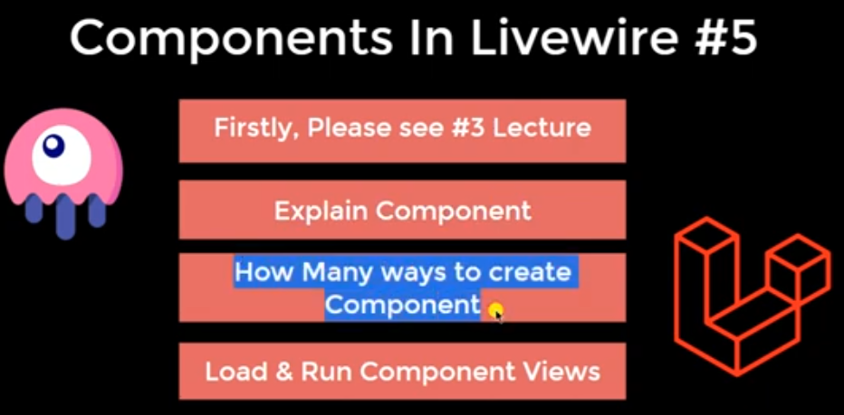

**Header**

**Php artisan make:livewire header**

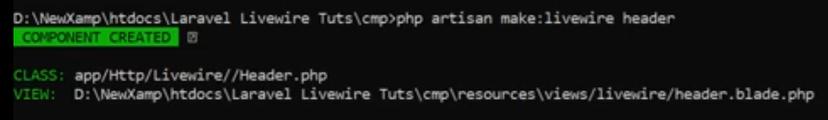

**Php artisan make:livewire footer –inline**

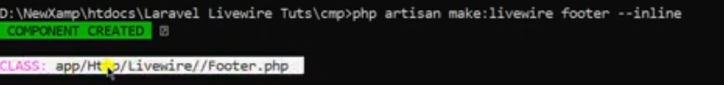

**Create only component**

